Document Specification
Title | 8-BIT TIMER
Author | Nguyen Minh Duc
Last Modified | October 31st, 2025
Version | 1.0

8-BIT TIMER
Synchronous design with APB Protocol

- OVERVIEW
  - Feature
The 8-bit timer module is a fully synchronous Verilog design that provides incrementing (counting up) and decrementing (count down) timing control for 8-bit values. It features multiple operating basic functions, including several clock modes, applying APB bus design and synchronous system design. A programmable prescaler enables different internal clock frequencies for adjustable timing resolution, while control and status registers manage configuration, initial count value, and interrupt flags. The timer supports overflow and underflow interrupts detection. With asynchronous reset, compact register interface, and low hardware resource usage, the design is easily scalable and suitable for FPGA or ASIC implementation.
  - Block Diagram
The block diagram of 8-bit timer design is defined in Figure 1.1. The design includes eleven inputs and five outputs, in which the prescaler block is used to provide four clock signals from the reference clock. Those clocks are different in frequencies for various clock speed modes. Inside the timer, the design uses five modules and four registers.
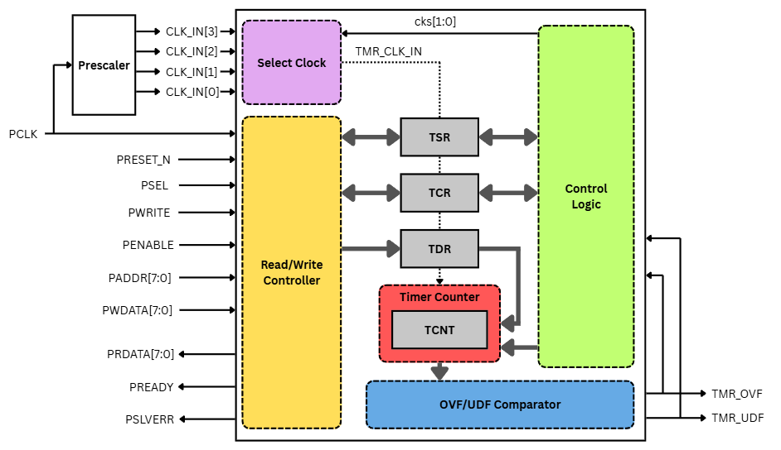
Figure 1.1. 8-bit Timer Block Diagram
  - Input/Outputs Pins (LSI pin – CHIP PIN/PORT)
The input and output pins used for 8-bit timer design is indicated in Figure 1.2 below.
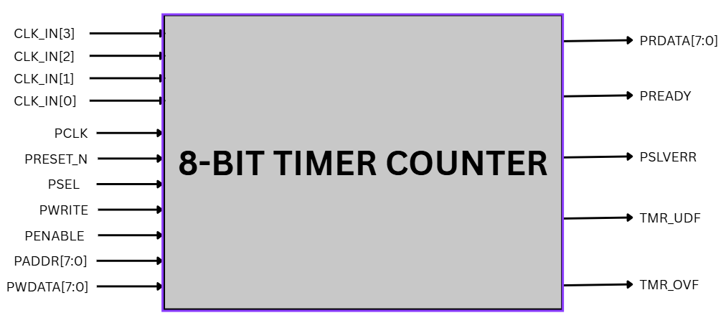
Figure 1.2. 8-bit Timer Input/Output Pins
The description for input and output pins is explained in Table 1.1 below.
Table 1.1. 8-bit Timer Port Description
PORT name | Attribute | BIT WIDTH | Description
CLK_IN[3]  …  CLK_IN[0] | Input | 1 | Prescaler clock signals.
PCLK | Input | 1 | Reference clock.
PRESET_N | Input | 1 | Asynchronous reset signal. (active low)
PSEL | Input | 1 | Chip select signal is HIGH for transfer.
PWRITE | Input | 1 | Read/Write signal. (LOW for read transfer and HIGH for write transfer)
PENABLE | Input | 1 | Enable signal is asserted to allow the data to be written/read and deasserted at the end of the transfer.
PADDR | Input | 8 | Address to select the register for the transfer.
PWDATA | Input | 8 | Write data. This bus is driven by the peripheral bus bridge unit during write  cycles when PWRITE is HIGH.
PREADY | Output | 1 | Ready signal from the slave to extend the transfer.
PRDATA | Output | 8 | Read data. This bus is driven by the peripheral bus bridge unit during write  cycles when PWRITE is LOW.
PSLVERR | Output | 1 | Error indicating signal of a transfer.
TMR_UDF | Output | 1 | Provided timer interrupt flag when counter count up from FF to 00
TMR_OVF | Output | 1 | Provided timer interrupt flag when counter count down from 00 to FF

  - Register Specification
The 8-bit timer module has 4 registers with different purposes, which are declared in Table 1.2. The internal bits of each register are described from Table 1.3 to Table 1.10
Table 1.2. Internal Registers Description
Offset | Register Name | Description | Bit Width | Access
0x01 | Timer Counter  (TCNT) | Hold current counting value | 8 | R/W
0x02 | Timer Data Register  (TDR) | Initial value to load into TCNT | 8 | R/W
0x03 | Timer Control Register  (TCR) | Control signals | 8 | R/W
0x04 | Timer Status Register  (TSR) | Interrupt status flags | 8 | R/W

- Timer Counter (TCNT)
TCNT is an 8-bit register that holds the current counting value of the timer. It can be cleared by asynchronous reset signal and the module can give two outputs – current counting value and next counting value. The bit explaination is displayed in Table 1.3 and 1.4.
Table 1.3. TCNT Bit Declaration
Bit 7 | Bit 6 | Bit 5 | Bit 4 | Bit 3 | Bit 2 | Bit 1 | Bit 0
tcnt[7] | tcnt[6] | tcnt[5] | tcnt[4] | tcnt[3] | tcnt[2] | tcnt[1] | tcnt[0]
Bit name | Attribute | Reset Value | Description
tcnt[7:0] | R/W | 8’h00 | Current counting value that can be loaded initial value from TDR when TCR[7] is asserted.
Table 1.4. TCNT Bit Description

- Timer Data Register (TDR)
TDR is an 8-bit register that can load the initial counting value for the timer.
Table 1.5. TDR Bit Declaration
Bit 7 | Bit 6 | Bit 5 | Bit 4 | Bit 3 | Bit 2 | Bit 1 | Bit 0
tdr[7] | tdr[6] | tdr[5] | tdr[4] | tdr[3] | tdr[2] | tdr[1] | tdr[0]
Bit name | Attribute | Reset Value | Description
tdr[7:0] | R/W | 8’h00 | 8 bits register for setting initial value counter for TCNT, range from 0 to 255 in decimal (00 to FF in hexadecimal).
Table 1.6. TDR Bit Description

- Timer Counter Control Register (TCR)
TCR is an 8-bit register whose bits are used for control the function of the timer.
Bit 7 | Bit 6 | Bit 5 | Bit 4 | Bit 3 | Bit 2 | Bit 1 | Bit 0
Load | Reserved | Up/Dw | En | Reserved | Reserved | cks1 | cks0
Table 1.7. TCR Bit Declaration

Table 1.8. TCR Bit Description
Bit name | Attribute | Reset Value | Description
Load[7] | R/W | 1’b0 | Manual load data from TDR to TCNT when it active HIGH.  0: Normal operation.  1: load data to TCNT
6 | Reserved | 1’b0 | Reserved
Up/Dw[5] | R/W | 1’b0 | 0: counter up  1: counter down
En[4] | R/W | 1’b0 | 0 : disable  1: enable
3:2 | Reserved | 2’b00 | Reserved
cks[1:0] | R/W | 2’b00 | Select internal clocks for circuit  00 : T*2  01 : T*4  10 : T*8  11: T*16
- Timer Statue Register (TSR)
TSR is an 8-bit register holding the overflow/underflow status for the timer.
Table 1.9. TSR Bit Declaration
Bit 7 | Bit 6 | Bit 5 | Bit 4 | Bit 3 | Bit 2 | Bit 1 | Bit 0
Reserved | Reserved | Reserved | Reserved | Reserved | Reserved | TMR_UDF | TMR_OVF
Table 1.10. TSR Bit Description
Bit name | Attribute | Reset Value | Description
7:2 | Reserved | 6’b0 | Reserved
TMR_UDF[1] | R/W* | 1’b0 | Timer counter underflow when counter 8’h00 down to 8’hff.  This bit is only set by hardware, clear by software
TMR_OVF[0] | R/W* | 1’b0 | Timer counter overflow when counter 8’hFF to 8’h00.  This bit is only set by hardware, clear by software
- READ/WRITE CONTROLLER
  - Input/Outputs Pins
The input and output pins used for Read/Write Controller is showed in Figure 2.1 below.

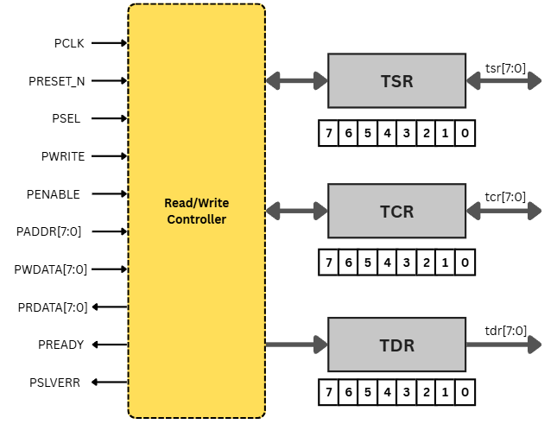
Figure 2.1. Read/Write Controller I/O Pins
This module uses the AMBA 3 APB Protocol to get access to the internal registers as TCNT, TCR, TDR and TSR. The APB provides a low-cost interface which is optimized for minimal power consumption and reduced interface complexity.
The port description for Read/Write Controller is defined in Table 2.1.

Table 2.1. Read/Write Controller Port Description
PORT name | Attribute | BIT WIDTH | Description
PCLK | Input | 1 | Reference clock.
PRESET_N | Input | 1 | Asynchronous reset signal. (active low)
PSEL | Input | 1 | Chip select signal is HIGH for transfer.
PWRITE | Input | 1 | Read/Write signal. (LOW for read transfer and HIGH for write transfer)
PENABLE | Input | 1 | Enable signal is asserted to allow the data to be written/read and deasserted at the end of the transfer.
PADDR | Input | 8 | Address to select the register for the transfer.
PWDATA | Input | 8 | Write data. This bus is driven by the peripheral bus bridge unit during write  cycles when PWRITE is HIGH.
PREADY | Output | 1 | Ready signal from the slave to extend the transfer.
PRDATA | Output | 8 | Read data. This bus is driven by the peripheral bus bridge unit during write  cycles when PWRITE is LOW.
PSLVERR | Output | 1 | Error indicating signal of a transfer.
tsr[7:0] | Reg | 8 | Timer Status Register value.
tcr[7:0] | Reg | 8 | Timer Control Register value.
tdr[7:0] | Reg | 8 | Timer Data Register value.

  - Functional/Protocol
The protocol of APB is unpipelined. All signal transitions are only related to the rising edge of the clock to enable the integration of APB peripherals easily into any design flow. Every transfer takes at least two cycles. The read/write transfers are described in Table 2.2.
Table 2.2. Read/Write Controller Function Description
Function | PWRITE | PSEL | PENABLE | PREADY | PSLVERR
WRITE | 1 | 1 | 1 | 0: unfinished transfer  1: the transfer is done | 0: no error  1: error when transfer (out-of-range address)
READ | 0 | 1 | 1 | 0: unfinished transfer  1: the transfer is done | 0: no error  1: error when transfer (out-of-range address)
  - State Machine
The state machine of the module is indicated in Figure 2.1 and Table 2.3 below.
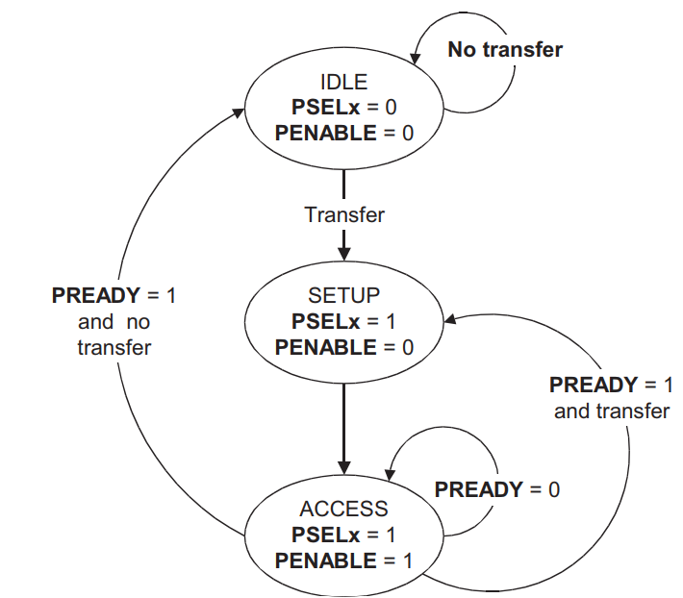
Figure 2.1. Read/Write Controller State Machine
Table 2.3. Read/Write Controller State Transition
Current State | Condition | Next State | PSEL | PENABLE
IDLE | No transfer request | IDLE | 0 | 0
IDLE | Transfer requested | SETUP | 1 | 0
SETUP | (After one cycle) | ACCESS | 1 | 1
ACCESS | PREADY = 0 | ACCESS | 1 | 1
ACCESS | PREADY = 1 and  new transfer | IDLE | 0 | 0
ACCESS | PREADY = 1 and  no new transfer | SETUP | 1 | 0

  - Design Circuit
Using 4-to-1 and 2-to-1 multiplexers to perform the write and read transactions for the internal registers as Figure 2.2.
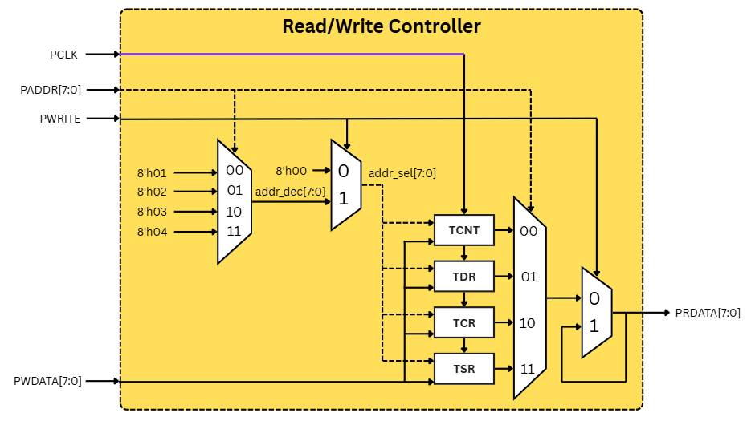
Figure 2.2. Read/Write Controller Design Circuit

  - Timing Chart
The timing chart for read/write transactions are referenced from the AMBA 3 APB Protocol v1.0 Specification.
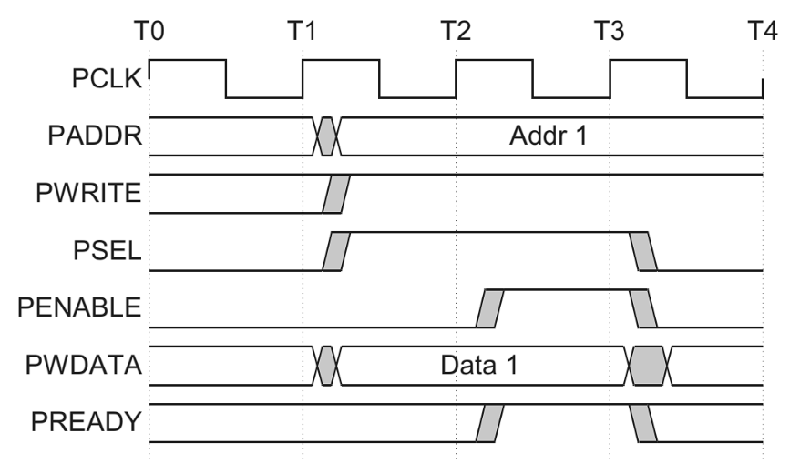
Figure 2.3. Write transfer with no wait states [1]
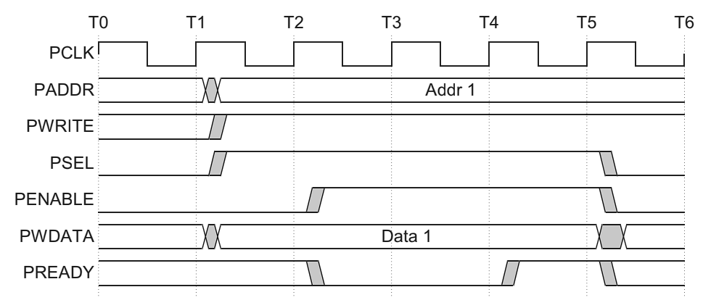
Figure 2.4. Write transfer with wait states [1]
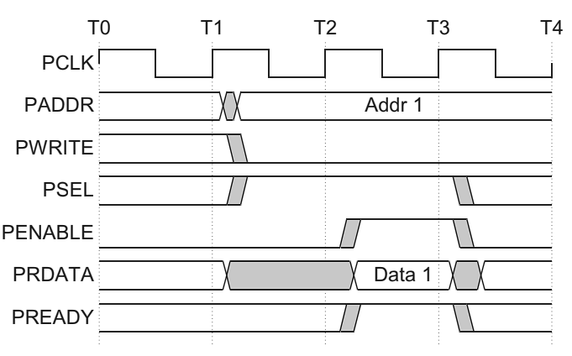
Figure 2.5. Read transfer with no wait states [1]
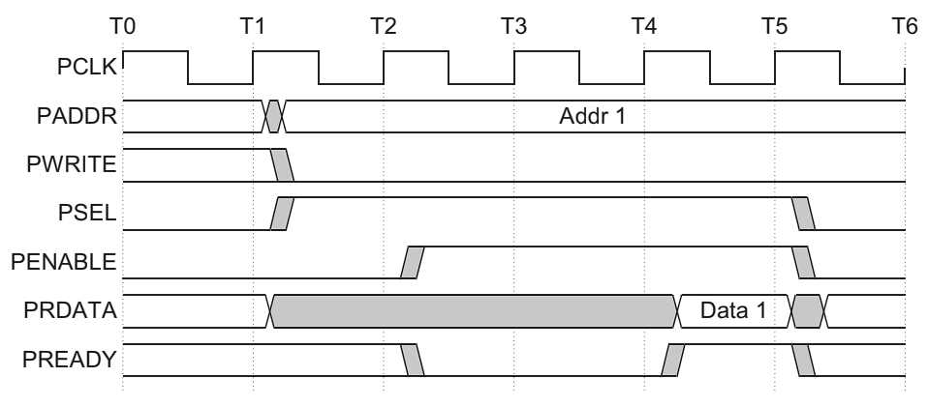
Figure 2.6. Read transfer with wait states [1]
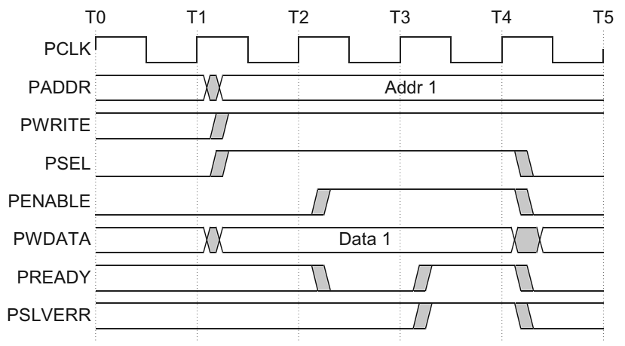
Figure 2.7. Example failing write transaction [1]
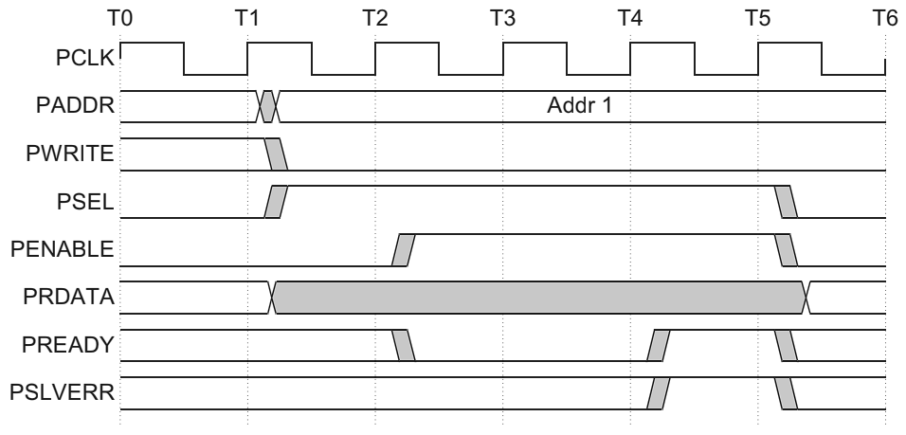
Figure 2.8. Example failing read transaction [1]

- PRESCALER & SELECT CLOCK
  - Input/Outputs Pins
The input/output pins used for Prescaler and Select Clock is showed in Figure 3.1 below.
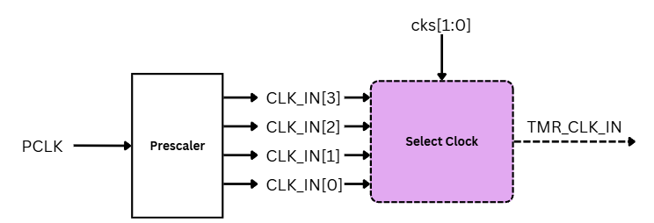
Figure 3.1. Prescaler and Select Clock I/O Pins
The port description for Prescaler and Select Clock is defined in Table 3.1.
Table 3.1. Prescaler and Select Clock Port Description
PORT name | Attribute | BIT WIDTH | Description
PCLK | Input | 1 | Reference clock.
CLK_IN[0]  CLK_IN [1]  CLK_IN [2]  CLK_IN [3] | Input | 1 | Clock signals with different frequencies.  00 – CLK_IN[0]: T*2  01 – CLK_IN[1]: T*4  10 – CLK_IN[2]: T*8  11 – CLK_IN[3]: T*16
cks[1:0] | Input | 1 | Clock select bits from TCR. Select which clock to be the timer clock.
TMR_CLK_IN | Wire | 1 | Timer Clock input signal. (TCNT input).

  - Functional/Protocol
The PCLK is divided by the Prescaler, then one of them are chosen and fed to the timer.
The protocol of Prescaler is displayed in Figure 3.2 below.
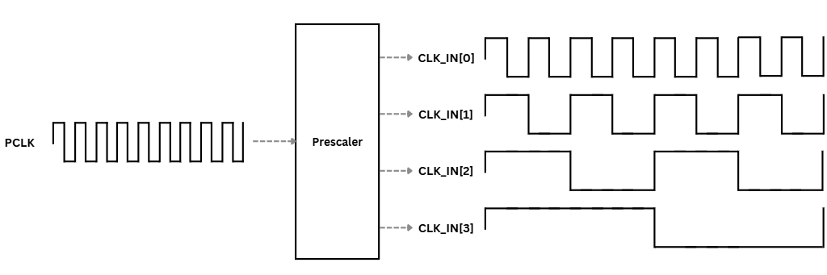
Figure 3.2. Prescaler Protocol
  - Design Circuit
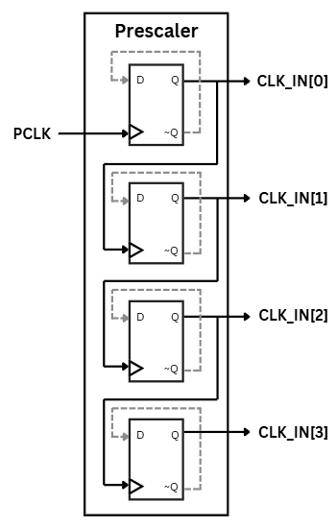
Figure 3.3. Prescaler Design Circuit
In the Select Clock, four internal clocks from CLK_IN[0] to CLK_IN[3], corresponding with division factors of 2, 4, 8 and 16. The bits cks[1:0] are used for choosing which clock is fed into the timer. The design circuit of Select Clock block is showed in Figure 3.4.
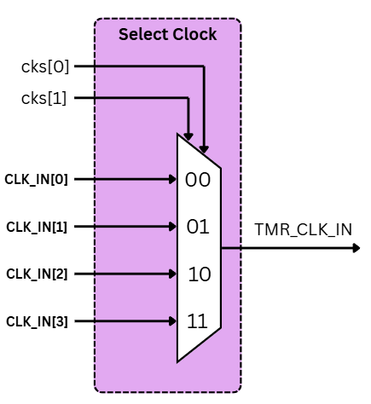
Figure 3.4. Select Clock Design Circuit
  - Timing Chart
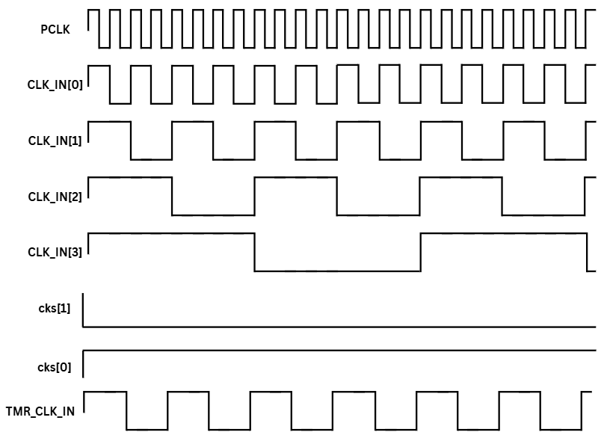
Figure 3.5. Prescaler & Select Clock Timing Chart (CLK_IN[1] selected)
- CONTROL LOGIC
  - Input/Outputs Pins
The input and output pins used for Control Logic is showed in Figure 4.1 below.
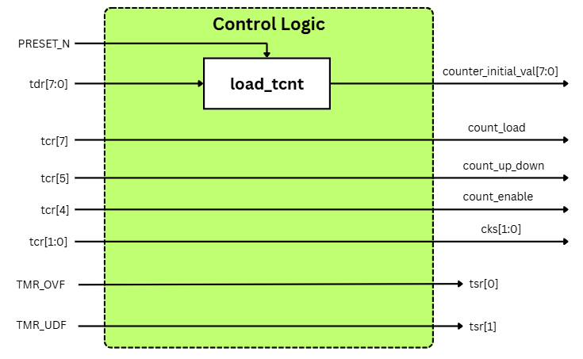
Figure 4.1. Control Logic I/O Pins
The Control Logic block is in charge of the timer operations based on the inputs of internal registers. The signals that the module handles include:
- tdr[7:0] – Initial counting value.
- tcr[7] – The control signal decides which input counting value is used.
- tcr[5] – The control signal chooses the operation of counting up or counting down.
- tcr[4] – The control signal enables the counting function.
- tcr[1:0] – The bits used for selecting the clock of the timer.
- tsr[0] – The clear bit for overflow status.
- tsr[1] – The clear bit for underflow status.

  - Functional/Protocol
The port description for Control Logic is indicated in Table 4.1.
Table 4.1. Control Logic Port Description
PORT name | Function | Register | Description
PRESET_N | Reset signal | System | Timer asynchronous reset signal.
reg_tdr[7:0] | Loaded Data | TDR | Initial value counter for TCNT. (counter_initial_val[7:0])
reg_tcr[7] | Load control signal | TCR | Load counter value from TDR register for counter starting value when enable count.
reg_tcr[5] | Up/Down | TCR | count_up_down control signal.  0: Count up  1: Count down
reg_tcr[4] | Enable | TCR | count_enable control signal.  0: Prevent counting  1: Enable counting
reg_tcr[1:0] | Internal clocks | TCR | Bits select clock for timer. (cks[1:0])  00 : T*2  01 : T*4  10 : T*8  11: T*16
TMR_OVF | Timer overflow status | TSR | reg_tsr[0] overflow control signal.  0: Overflow hold  1: Overflow clear
TMR_UDF | Timer underflow status | TSR | reg_tsr[1] underflow control signal.  0: Underflow hold  1: Underflow clear

  - Design Circuit
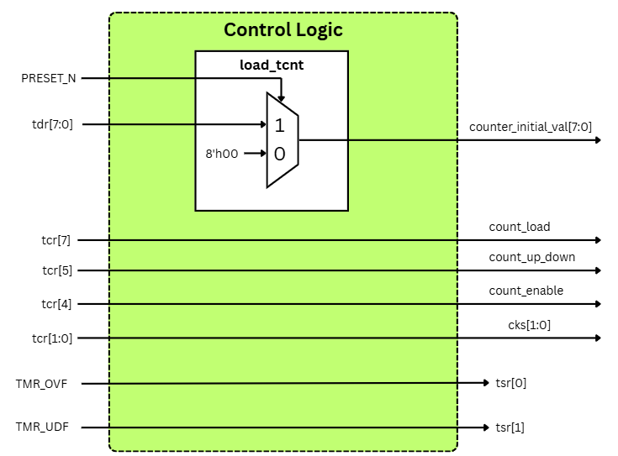
Figure 4.2. Control Logic Design Circuit
  - Timing Chart
No need due to all circuits using inside control logics are combination logic. These logics will be update value immediately without clock signal.

- TIMER COUNTER (TCNT)
  - Input/Outputs Pins
Figure 5.1 below shows the input/output pins of the Timer Counter block.
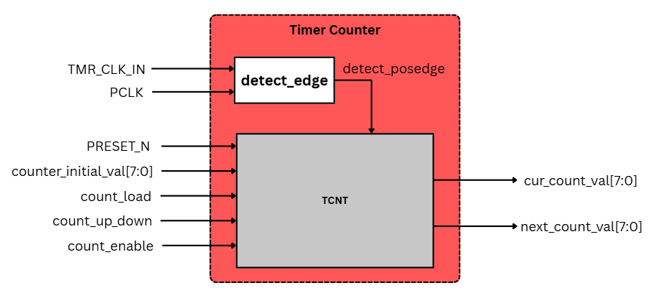
Figure 5.1. Timer Counter I/O Pins
The port description for Timer Counter is indicated in Table 5.1.
Table 5.1. Timer Counter Port Description
PORT name | Attribute | Bit Width | Description
TMR_CLK_IN | Wire | 1 | The clock selected from Control Logic.
PCLK | Input | 1 | Provided clock for APB protocol.
detect_posedge | Wire | 1 | Detect positive edge of the clock.
PRESET_N | Input | 1 | Timer asynchronous reset signal.
counter_initial_val[7:0] | Wire | 8 | Preload starting count value.
count_load | Wire | 1 | 0: Normal operation.  1: Load data into TCNT.
count_up_down | Wire | 1 | 0: Count up  1: Count down
count_enable | Wire | 1 | 0: Prevent counting  1: Enable counting
cur_count_val[7:0] | Wire | 8 | Current counting value of the timer.
  - Functional/Protocol
The Timer Counter is responsible for performing the counting up/down algorithm based on the control inputs from Control Logic. A functional block called detect_edge is designed to detect the positive edge of the clock using the reference clock and timer clock as inputs.
The basic functional process:
- PRESET_N will reset the value of reg_tcnt[7:0] to 8’h00.
- count_load signal decides whether the initial counting value from TDR or the reg_tcnt[7:0] is used for counting.
- After waiting one cycle, in the next positive edge of the clock, based on the count_up_down signal, the result is incrementing/decrementing.
- The count_enable signal enables the next counting output of the timer, or else it holds the previous value.
  - Design Circuit
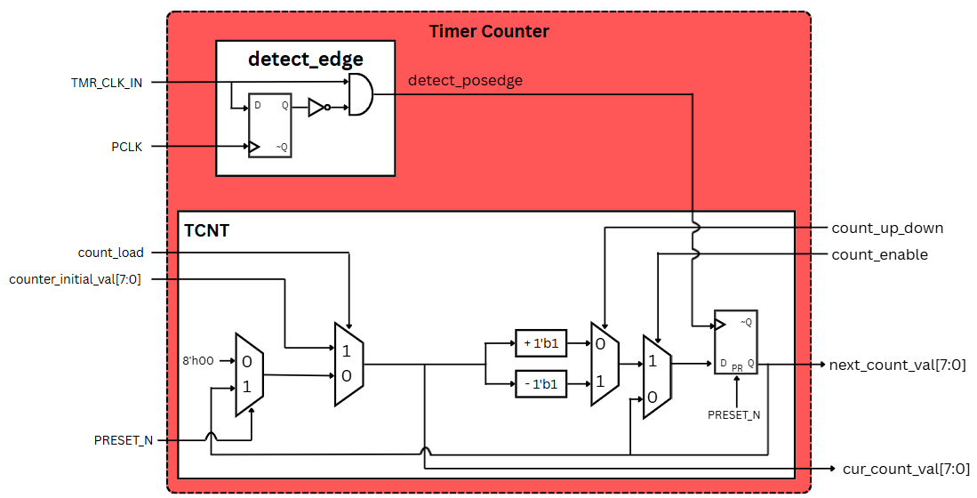
Figure 5.2. Timer Counter Design Circuit

  - Timing Chart
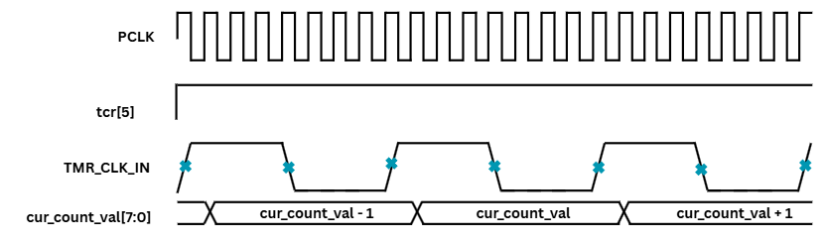
Figure 5.3. Count Up Functional Timing Chart

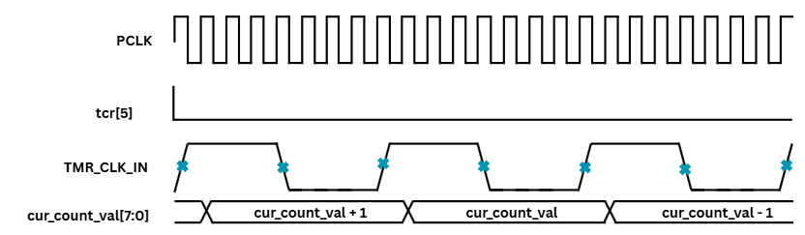
Figure 5.4. Count Down Functional Timing Chart

- OVERFLOW/UNDERFLOW COMPARATOR
  - Input/Outputs pin
Figure 6.1 below shows the input/output pins of the Overflow/Underflow Comparator.
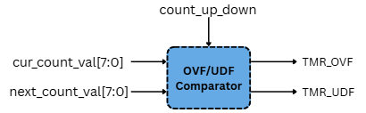
Figure 6.1. Overflow/Underflow Comparator I/O Pins
The port description for Overflow/Underflow Comparator is indicated in Table 6.1.
Table 6.1. Overflow/Underflow Comparator Port Description
PORT name | Attribute | Bit Width | Description
cur_count_val[7:0] | Wire | 8 | Current counting value.
next_count_val[7:0] | Wire | 8 | Next counting value.
count_up_down | Wire | 1 | Count up/down signal.
TMR_OVF | Output | 1 | Overflow status signal.
TMR_UDF | Output | 1 | Underflow status signal.
  - Functional/Protocol
The Overflow/Underflow Comparator detects the overflow or underflow status:
- In counting up function (count_up_down = 1’b0), when cur_count_val[7:0] = 8’hFF and next_count_val[7:0] = 8’h00, the TMR_OVF is set HIGH by TSR for one cycle to annouce the overflow status.
- In counting down function (count_up_down = 1’b1), when cur_count_val[7:0] = 8’h00 and next_count_val[7:0] = 8’hFF, the TMR_UDF is set HIGH by TSR for one cycle to annouce the underflow status.

  - Design Circuit
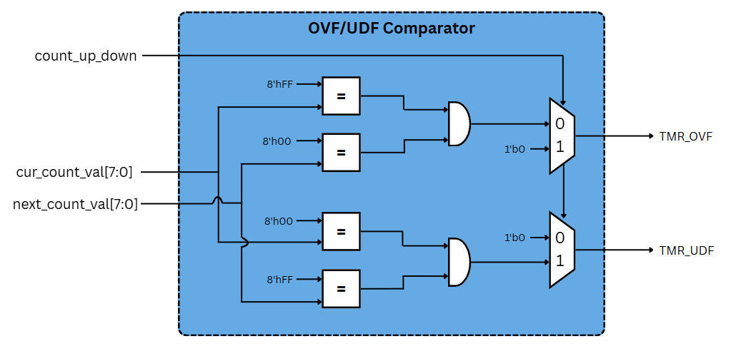
Figure 6.2. Overflow/Underflow Comparison Design Circuit
  - Timing Chart
TMR_OVF is set HIGH at the final cycle before counter changes from 8’hFF to 8’h00.
Reg_TCR[7]
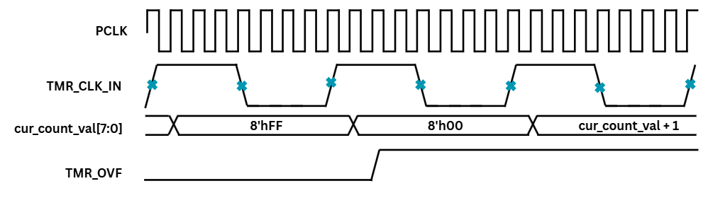
Figure 6.3. Overflow Timing Chart
TMR_UDF is set HIGH at the final cycle before counter changes from 8’h00 to 8’hFF.
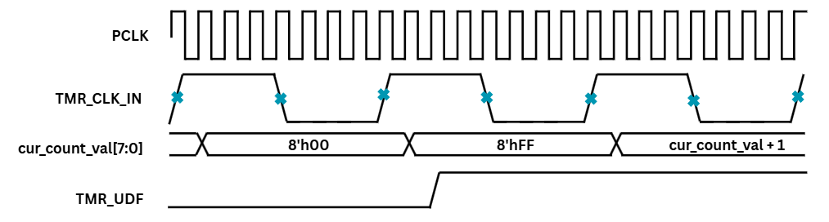
Figure 6.4. Underflow Timing Chart

REFERENCES
[1] | ARM Limited, 2003-2004. AMBA 3 APB Protocol v1.0 Specification.  (ARM IHI 0024B)

